**Exp no: 3**

**Write a program to find minimum of function *f* (*x*, *y*)=*x* 2 +*y* 2 +4 using gradient**

**descent algorithm**

**AIM:**

To compute the value of the variables “x” and “y” at the minimum value of the objective

function using NumPy

**INTEGRATED DEVELOPMENT ENVIRONMENT (IDE) REQUIRED:**

JUPYTER NOTEBOOK

**REQUIRED LIBRARIES FOR PYTHON:**

∙ Numpy

**PROCEDURE:**

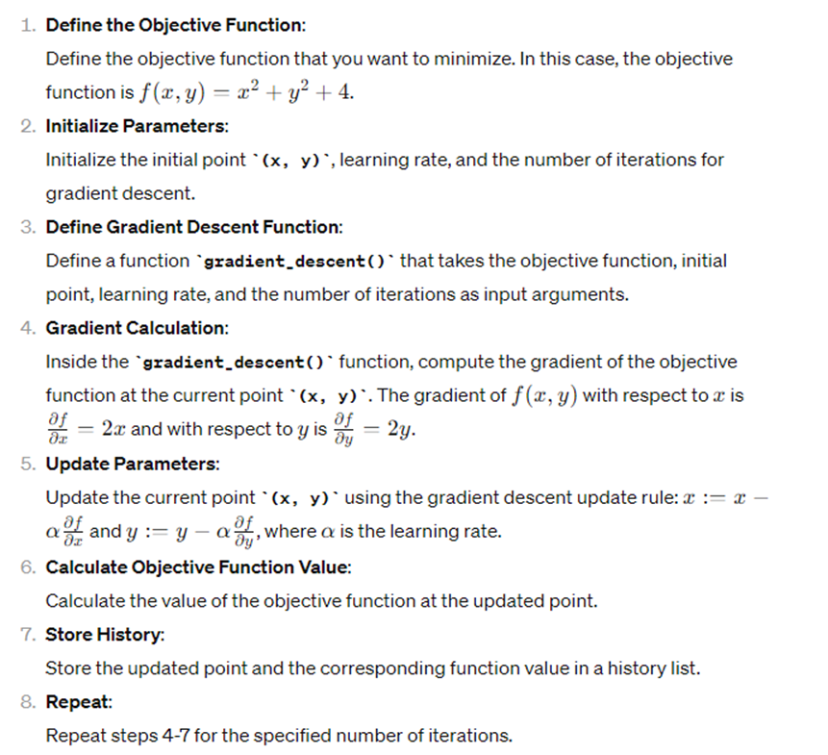

**PROGRAM:**

import numpy as np

def gradient_descent(f, initial_point, learning_rate, iterations):

point = initial_point.copy()

history = []

for _ in range (iterations):

# Compute gradient of the function at the current point

gradient = np.array([2 * point[0], 2 * point[1]])

# Update point using gradient descent update rule

point -= learning_rate * gradient

# Calculate the value of the function at the updated point

value= f(point [0], point[1])

# Save the history of points and function values

history.append((point.copy(), value))

print("Values of points and objective function value are: () and {}".format(point, value))

return point, history

def objective_function(x, y):

return x**2 + y**2 + 4

# Define initial point, Learning rate, and number of iterations

initial_point = np.array([1.0, 1.0])

learning_rate = 0.1

iterations = 100

# Run gradient descent

minimum_point, history = gradient_descent(objective_function, initial_point, learning_rate, iterations)

print("Minimum point (x, y):", minimum_point)

print("Minimum value of the function:", objective_function(*minimum_point))

**OUTPUT:**

OUTPUT FOR EVERY 10 ITERATIONS

Values of points and objective function value are: [0.8 0.8] and 5.28

Values of points and objective function value are: [0.08589935 0.085899

35] and 4.014757395258967

Values of points and objective function value are: [0.00922337 0.009223

37] and 4.00017014118346

Values of points and objective function value are: [0.00099035 0.000990

35] and 4.000001961594292

Values of points and objective function value are: [0.00010634 0.000106

34] and 4.000000022615643

Values of points and objective function value are: [1.14179815e-05 1.14

179815e-05] and 4.000000000260741

Values of points and objective function value are: [1.22599643e-06 1.22

599643e-06] and 4.0000000000030065

Values of points and objective function value are: [1.31640365e-07 1.31

640365e-07] and 4.000000000000035

Values of points and objective function value are: [1.41347765e-08 1.41

347765e-08] and 4.0

Values of points and objective function value are: [1.51771007e-09 1.51

771007e-09] and 4.0

Minimum point (x, y): [2.03703598e-10 2.03703598e-10]

Minimum value of the function: 4.0

**Result:** The program finds the minimum value of the objective function as 4.0